Basketball Shot Tracker — Lab Report: Second-Gym Test, Dev Fixes and the iPhone App
Oct 11, 2026

Abstract
Between 2026-10-05 and 2026-10-11 the shot tracker went from a PC-only system to a live iPhone app. Retraining the YOLOv8s ball/hoop detector on phone footage of busy gyms, plus three tracker changes, raised re-test accuracy from 77.7% to 92.2% on public test videos and from 13.4% to 78.2% on our own footage (section 5). The first clean, first-look number followed on 2026-10-09: the frozen system called 85.6% of 90 blind-labelled shots right (95% CI 77–91%) in a second gym it had never seen, finding 87 of the 90 and inventing none; 9 of its 13 errors were makes called missed (section 8). Fixes made afterwards for exactly those errors reach 94–95% on development footage but are not yet tested (section 9). The same detector, tracker and shot judge now run live on an iPhone 11 at 28–32 detector frames per second: its boxes match PyTorch's within 0.7 px, the Swift port of the shot logic matches the Python code exactly on 33,386 frames, and Python replays of phone recordings make the same calls (section 10). Live accuracy on the phone is the next measurement.

1. Background and objectives
The project is a computer-vision system that watches a fixed phone camera and calls each basketball shot made or missed, live on the user's own iPhone 11. Before this work it scored 77.7% end-to-end (95% CI 69–85%) on 103 held-out shots from 16 public phone videos, but its detector had been trained only on about four mostly indoor, broadcast-style source videos, and it ran only in Python on a PC.
Objectives:
- Measure the system on footage that matches the app's real use: our own iPhone sessions with several people on court.
- Find and fix the causes of failure on that footage without tuning on test data.
- Measure the effect honestly and check what the system needs to run on a phone.
- Get a first-look test number on footage from a place no part of the system had seen.
- Run the system live on the iPhone 11, without a Mac or a paid developer account, and show that the phone computes the same calls as the Python reference.
Rules kept throughout: shots are labelled by hand before any tracker output is seen; data is split by whole video into dev (tune freely) and test (scored once, frozen code); every number states what it measures.

2. Timeline
The work ran over seven days, newest first.
Date | Step | What happened
2026-10-11 | Documentation | App README and report with figures; research results updated; this report
2026-10-11 | Exact phone replays | Shot judge restarts when recording starts; a 74 s recording replays 6 of 6 calls identically in Python (build d29f83c)
2026-10-10 | Phone recordings | Record, Sessions screen and Export in the app; import_phone_session.py replays recordings through the Python code
2026-10-10 | Swift port | Tracker and shot judge ported to Swift; identical to Python on 4 golden cases (33,386 frames, 123 calls)
2026-10-10 | Detector on the phone | Detector v2 converted to Core ML (fp16); boxes match PyTorch on 24 dev frames; two-stage pipeline at 27 fps
2026-10-10 | Frame-rate fix | Held-ball check made a speed; second gym at 20 fps: 89–92 to 95–97 of 102 dev shots
2026-10-10 | Toolchain | Swift, xtool and free Apple ID signing in WSL Ubuntu; iPhone reached through the Apple Devices relay
2026-10-09 | Dev fixes | Net catch, hoop found from rim boxes, shot rules in rim widths, front-rim shots
2026-10-09 | First-look test | System frozen (15:07) and scored once on second-gym sessions 6–8: 85.6%
2026-10-09 | Filming, labelling | Seven sessions in a second gym (morning); 192 shots labelled blind; split fixed before anything ran
2026-10-08 | Detectors v3, v4 | 8 more epochs, and 600 hand-boxed own frames; both lost dev shot calls; v2 kept
2026-10-07 | Shot-judge changes (dev) | Balls leaving through the top followed back down; bounced-back-out rule; net braking 1.3
2026-10-07 | App port preparation | Settings and golden test cases exported; least squares rewritten so the app can reproduce it exactly
2026-10-07 | Speed sweep | Accuracy measured at 640 / 960 / 1280 px and 60 / 30 / 20 fps on dev footage
2026-10-07 | Frozen re-test | Current system scored once on both test sets: 92.2% public, 78.2% own
2026-10-07 | Settings check | An apparent tracker regression traced to a wrong image size; safeguards added
2026-10-07 | Dev comparison | New vs old detector on dev footage, same hoops and tracker
2026-10-06 to 07 | Detector v2 training | 12 epochs overnight on 8,347 images (first attempt crashed at 17:00, restarted 22:50, done 06:52)
2026-10-06 | Dataset build | Hooper v6 checked (licence, labels, box style) and merged with hotshot
2026-10-06 | Dataset search | Roboflow Universe candidates compared by licence, size, classes and camera view
2026-10-06 | First own-footage test | Tracker v2 + old detector scored once on sessions 2–4: 37.8%
2026-10-06 | Tracker v2 | Diagnosis on dev session 1, then three tracker changes
2026-10-06 | Labelling | 162 shots labelled blind with made/missed and shot type; sessions 1 and 2 trimmed
2026-10-06 | Setup | Videos imported, split fixed, hoop boxes set, tools generalised for new footage
2026-10-05 | Filming | Four indoor sessions recorded between 20:01 and 20:15

3. Materials
Three kinds of data were used, never mixed: evaluation footage (scored against hand labels), training datasets (for the detector) and recordings made by the app (to check the phone against Python).

3.1 Own iPhone sessions, first gym
Four indoor sessions, iPhone 11 (0.5× ultra-wide lens) on a tripod at the sideline: hoop at the top left of the frame, shooters on the right, and the rim only about a fifth of the frame below the top edge; 1920×1080, 59.94 fps, H.264; three people taking turns. The split was fixed before any tracker output was seen.
Session | Split | Length | Shots labelled (made) | FT / mid / 3PT | Notes
1 | Dev | 3:16 | 43 (16) | 11 / 14 / 18 | Two balls in play at times; first 27 s (form shooting) trimmed
2 | Test, dev from 10-07 | 4:11 | 41 (5) | 10 / 15 / 16 | First 35 s (warm-up) trimmed
3 | Test, dev from 10-07 | 3:37 | 39 (21) | 10 / 14 / 15
4 | Test, dev from 10-07 | 3:40 | 39 (11) | 10 / 15 / 14
Labelling: one row per shot (time the ball reaches the hoop, made or missed, shot type), made with a key-press tool that never shows predictions. Predictions match a label within ±1.5 s. Trims were re-encoded at near-lossless quality and checked frame by frame (first frame at 27.01 s and 35.00 s of the originals). Sessions 2–4 had been scored twice by 2026-10-07 (section 5.2 and the first own-footage test), so from then on they are dev footage (section 7).

3.2 Own iPhone sessions, second gym (new)
Seven indoor sessions filmed on the morning of 2026-10-09 in a second gym that no detector, rule or threshold had seen: one shooter, one ball, iPhone 11 (0.5×) on a tripod at the sideline, the rim about a third of the way down the frame; 1920×1080, 60 fps, H.264. The split was fixed before anything ran on them: the three sessions of a single shot type (6, 7, 8) are test, the four freestyle sessions are dev. Shots were labelled blind as above.
Session | Split | Length | Shots labelled (made) | FT / mid / 3PT | Notes
5 | Dev | 4:46 | 30 (12) | 10 / 10 / 10
6 | Test | 4:14 | 30 (19) | 30 / 0 / 0 | Free throws only
7 | Test | 4:18 | 30 (19) | 0 / 30 / 0 | Mid-range only
8 | Test | 4:51 | 30 (15) | 0 / 0 / 30 | Threes only
9 | Dev | 3:59 | 25 (13) | 10 / 10 / 5
10 | Dev | 2:12 | 14 (7) | 10 / 0 / 4
11 | Dev | 5:42 | 33 (19) | 10 / 10 / 13 | A second backboard of similar size in view

3.3 Public phone videos (existing)
16 portrait videos (1080×1920, ~60 fps; indoor/outdoor, ground/tripod camera, free throws and threes), 201 hand-labelled shots: 8 dev videos (98 shots) and 8 test videos (103 shots). No licence, so used locally only.

3.4 Detector training data
Dataset | Licence | Images used | Classes used | Notes
hotshot v5 (Roboflow) | CC BY 4.0 | 3,023 train / 190 val | ball, hoop (rim + net) | The original training set
Basketball Detection v6 by Hooper (Roboflow) | CC BY 4.0 | 5,324 train / 690 val | ball, rim_only | Phone video of gyms with many people; every 8th of 48,110 frames; validation = whole 2,000-frame blocks
Hooper's hoop boxes cover the rim only (about 4× wider than tall), unlike hotshot's rim-and-net boxes, so they became a separate class the tracker ignores; its boxes around people were dropped. No frames from any evaluation footage were used for training detector v2. For the detector v4 experiment (section 7.3), 600 frames of first-gym dev sessions 1, 2 and 4 were boxed by hand; v4 was not kept.

3.5 Recordings made by the app (new)
Three recordings made with the app on 2026-10-10 and 11 by pointing the phone at a monitor showing gym video. They are not labelled and are used only to check that the phone computes the same calls as the Python code (section 10.7).

4. Methods
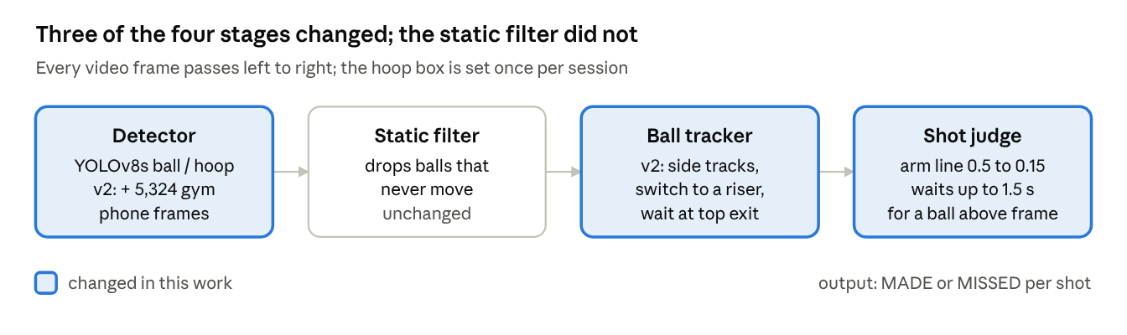
pipeline stages and what changed, 2026-10-05 to 07
The detector, the ball tracker and the shot judge changed; each change was chosen on dev footage only. The methods of the later work are described with their results (sections 7–10).

4.1 Tools and environment
Item | Used for
PC: Windows 10, NVIDIA GTX 1660 SUPER (6 GB) | Training and running the Python system
iPhone 11 on a tripod | Filming (1080p, 60 fps, landscape) and running the app
Python 3.10, PyTorch 2.14 (CUDA 12.6), Ultralytics 8.4 (YOLOv8s) | Detector training and inference
OpenCV, NumPy | Video reading, drawing, geometry
imageio-ffmpeg | Frame-accurate trimming of sessions 1 and 2
Roboflow Universe | Finding and downloading the extra training dataset
pytest, GitHub Actions | 110 automated Python tests on every push (88 on 2026-10-07)
WSL Ubuntu: Python 3.12, coremltools 9.0, PyTorch 2.7 (CPU) | Converting the detector to Core ML (coremltools does not run on Windows)
Swift 6, SwiftUI, AVFoundation, Core ML | The iPhone app; its ShotCore package (22 tests with Swift Testing)
xtool, swiftly, free Apple ID, Apple Devices relay | Building, signing and installing the app from Windows without a Mac
Project scripts | label_shots.py (blind labelling), mark_hoop.py, run_eval_videos.py, evaluate.py, compare_runs.py (side-by-side scoring), debug_video.py + replay_eval.py (fast replays on dev), build_combined_dataset.py, train_detector.py, shot_report.py (every shot drawn), export_coreml.py, export_parity_frames.py, export_app_fixtures.py, import_phone_session.py

4.2 Tracker v2
Diagnosis on dev session 1 found three failure causes, each with one fix:
- Fake balls on people. The detector fired on heads, calf sleeves and hands at 0.6–0.8 confidence, and the single-target tracker locked onto them. Fix: other detections are kept as short side tracks; one that rises fast for 4 frames (at least 12 ball-widths per second, mostly upward) takes over from a main track moving at under half that speed.
- Ball lost near the apex. High arcs left the top of the frame or vanished against ceiling lights for about 0.5 s, and the tracker restarted on a leg. Fix: when the track was heading out of the top, tracker and shot judge wait up to 1.5 s for the ball to reappear near where it left.
- Arm line too high. A low camera near the hoop makes the hoop box tall, so many arcs never rose 0.5 hoop-heights above the rim. Fix: 0.15 hoop-heights.

4.3 Detector v2
Fine-tuned from the original detector on the combined dataset (8,347 training images, 880 validation): 12 epochs, image size 960 px, batch size 2, early stopping patience 5, about 47 minutes per epoch. Batch size 4 needed about 8 GB on the 6 GB card and the first attempt ended in a graphics-driver reset after 15 minutes; batch size 2 fit in 5.8 GB.

4.4 Measurement safeguards
- Label files and code are fingerprinted (SHA-256) and copied before any test run.
- Runs record their settings (weights, image size, frame step); compare_runs.py warns when compared runs differ.
- Image size defaults to 1280 px for portrait video and 960 px for landscape.
- A test run first writes a FROZEN file: code commit, and SHA-256 of the detector weights, label files, hoop file and videos (second-gym test: 2026-10-09 15:07, before its single scoring run).
- The app shows its build's git commit on the start screen and writes it, with the model's SHA-256, into every recording.
- The Swift port is tested against golden cases exported from the Python code, compared exactly (section 10.5).

5. Results
The system of 2026-10-07 (detector v2 + tracker v2) scores 92.2% on the public test videos and 78.2% on our own test sessions, both clear gains with non-overlapping 95% intervals. End-to-end accuracy counts a shot as right only if it is found and called correctly.

5.1 Frozen re-test: public test videos (8 videos, 103 shots)
Settings matched the original run: 1280 px, every 2nd frame, the same hoop boxes.
Metric | Original (2026-10-02) | System of 2026-10-07
End-to-end accuracy (95% CI) | 77.7% (69–85%) | 92.2% (85–96%)
Shots found (recall) | 82.5% | 96.1%
Precision (found shots that were real) | 98.8% | 99.0%
Made/missed correct on found shots | 94.1% | 96.0%
Outdoor / indoor | 66.7% / 88.5% | 90.2% / 94.2%
Free throws / threes | 84.5% / 68.9% | 89.7% / 95.6%
The old weak spot, video 2 (outdoor, camera on the ground, threes), went from 3 to 11 of 12 shots right.

5.2 Frozen re-test: own sessions 2–4 (119 shots)
Settings: 960 px, every frame, hoop boxes set once per session.
Metric | Old detector + original tracker | Old detector + tracker v2 (2026-10-06) | System of 2026-10-07
End-to-end accuracy (95% CI) | 13.4% (8–21%) | 37.8% (30–47%) | 78.2% (70–85%)
Shots found (recall) | 18.5% | 44.5% | 86.6%
Precision | 95.7% | 100% | 98.1%
Made/missed correct on found shots | 72.7% | 84.9% | 90.3%
Free throws / mid-range / threes | — | 60.0% / 38.6% / 22.2% | 76.7% / 70.5% / 86.7%
By session, the system found 27/41, 37/39 and 39/39 shots; session 2 holds most of the remaining misses. Among found shots, 5 makes were called misses and 5 misses called makes.

5.3 Which tracker change matters (dev, replay)
Each tracker-v2 change switched off in turn, with detector v2 at 960 px.
Tracker | Old dev videos (98 shots) | Dev session 1 (43 shots)
Original | 89.8% | 62.8%
Tracker v2, all changes | 89.8% | 86.0%
v2 without switching | 89.8% | 74.4%
v2 without the top-exit wait | 89.8% | 76.7%
v2 without the lower arm line | 89.8% | 79.1%
On side-on footage the changes alter nothing (the same shots right and wrong); on our footage each adds 7–12 points.

5.4 Detector v2 training
Validation on 880 held-out images after 12 epochs: precision 0.871, recall 0.823, mAP50 0.851 (ball 0.747, hoop 0.931, rim_only 0.876), mAP50-95 0.433. Before training, the original detector found only 53 of 242 labelled balls in a random sample of 300 Hooper frames at 0.5 confidence.

6. Speed vs accuracy for a phone app
The phone can run the detector at 20 frames per second and, for landscape video, at 640 px with little or no loss: our footage stays at 84–88% at every setting tested.
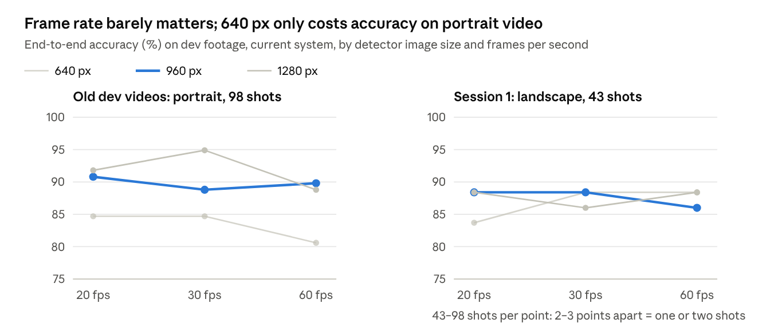
replays of every-frame detections, dev footage only, 2026-10-07
Detector time on the PC graphics card for one 1920×1080 frame: 12.7 ms at 640 px, 19.4 ms at 960 px, 31.6 ms at 1280 px. Lower frame rates were simulated by skipping frames in the every-frame detections, which gives the same result as a live run at that rate.
Recommended app setting on 2026-10-07: landscape filming, 960 px at 20–30 fps, falling back to 640 px if the iPhone 11 could not keep up. The app now runs 960 px at 28–32 detector frames per second (section 10.4), and the simulated frame rates later exposed a frame-rate dependence in the shot judge (section 10.6).

7. More dev work before the second-gym test (2026-10-07 to 08)
Sessions 2–4 had now been scored twice, so they could no longer give a clean first-look number; from here on all four first-gym sessions are dev footage, and the next test number comes from newly filmed sessions. Everything in this section went into the system frozen for that test (commit c78a239) or, for detectors v3 and v4, was rejected before it.

7.1 Balls that leave through the top of the frame
Session 2 held 14 of the 16 shots the system never found. In 11 of them the ball left through the top of the frame for 0.8–1.2 s. Mid-range shots close to the camera slowed down on screen while hidden (they flew away from the camera), so the constant-velocity guess put the re-entry 400–900 px past where the ball came back and the tracker ignored it; in 3 more the shot judge saw only the falling half. Fixes: when a ball that left through the top was heading for the hoop, the tracker also searches between the exit point and one hoop-width past the hoop; and a gap that starts with the ball rising out of the top and ends with it back above the rim counts as one flight.
Dev replays, detector v2, 960 px | Before | After
Session 2 | 58.5% (25 of 41 found) | 82.9% (39 of 41 found)
Sessions 1, 3, 4 | 86.0% / 84.6% / 89.7% | Identical (same shots right and wrong)
All first-gym sessions (162 shots) | 79.6% (95% CI 73–85%), recall 89.5% | 85.8% (80–90%), recall 98.1%
Public dev videos (98 shots, 1280 px) | 94.9% | 94.9% (identical)

7.2 Made / missed rules
With shots now found, 20 of the 23 errors left on first-gym footage were wrong made/missed calls. The ball's motion in the 0.45 s after it crossed the rim line was compared between right and wrong calls on all 255 matched dev shots:
- Bounced back out. Five misses called made moved back towards the shooter by 0.9–1.4 hoop widths while still at net height (they hit the back of the rim or the board); no correct make moved back more than 0.62. Moving back by 0.75 hoop widths before dropping below the net is now a miss.
- Net braking. A make was demoted to "fell past the rim" whenever the ball was not slowed going through the net (falling speed after / before at least 1.0). Eight first-gym makes reached 1.1–1.35; balls that really fell past were mostly 1.8–2.7. The threshold was raised to 1.3, which keeps the simulator's fall-past detection intact at realistic noise.
Together: first-gym dev footage 85.8% to 92.0%, public dev videos 94.9% to 93.9% (one shot). These are dev numbers, tuned on the shots they are measured on.

7.3 More detector training did not help shot calls (v3, v4)
Two retrained detectors were compared with detector v2 on the same tracking and judging code, on dev footage only. Both were fine-tuned from v2's weights for 8 more epochs at a small learning rate.
 | v2 (kept) | v3: 8 more epochs, same data | v4: + 600 hand-boxed own frames
Validation mAP50 / mAP50-95 (880 images) | 0.851 / 0.433 | 0.866 / 0.442 | 0.849 / 0.424
First-gym sessions, shot calls | 92.0% (1–4) | 90.7% (1–4) | 89.7% (session 3, held out; v2 92.3%)
Public dev videos, shot calls | 93.9% | 88.8% | 85.7%
v3 saw the ball in up to 5 points fewer frames of the public videos: more epochs on the same data specialised it. v4 was the better detector on held-out session 3's frames (balls found 87.7% vs 82.4%, false balls 5 vs 12), but saw the ball in 4–16 points fewer frames on every public video and did not find the hoop in the second gym at all: one gym's frames taught it one gym. Validation mAP is not the deciding number; shot calls on footage the model never saw are. v2 stays the detector.

8. First-look test in a second gym (2026-10-09)
The system was frozen and fingerprinted before a single scoring run (2026-10-09 15:07): Python commit c78a239, detector v2 (SHA-256 e90e448a…), 960 px, every frame, ball confidence 0.15, hoop marked by hand. The test sessions 6–8 had been labelled blind, and nothing had been run on them before.
Test: sessions 6–8, 90 shots | Result
End-to-end accuracy (found and called right) | 85.6% (77 of 90; 95% CI 77–91%)
Shot detection: precision / recall / F1 | 100% / 96.7% / 98.3% (87 of 90 found, none invented)
Made/missed correct on found shots | 88.5% (77 of 87)
Free throws / mid-range / threes | 76.7% / 90.0% / 90.0%
Session | Shot type | Found | Called right | Makes labelled / called made
6 | Free throws | 28 of 30 | 23 (76.7%) | 19 / 13
7 | Mid-range | 29 of 30 | 27 (90.0%) | 19 / 17
8 | Threes | 30 of 30 | 27 (90.0%) | 15 / 14
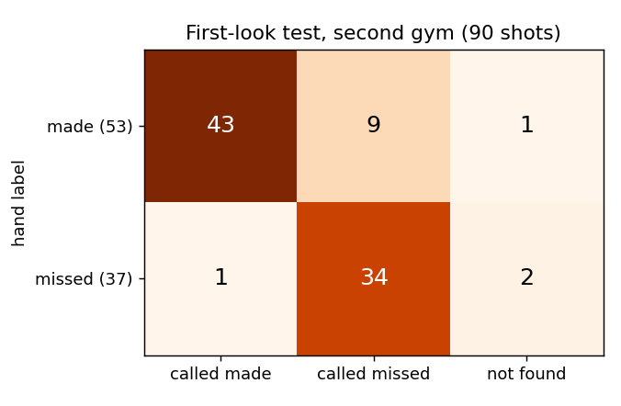
rows: hand label; columns: the system's answer; second-gym test, 90 shots
Class | Precision | Recall | F1
Made | 97.7% (43 of 44 called made) | 82.7% (43 of 52 found makes) | 89.6%
Missed | 79.1% (34 of 43 called missed) | 97.1% (34 of 35 found misses) | 87.2%
Shot found | 100% (87 of 87) | 96.7% (87 of 90) | 98.3%
The errors lean one way. 9 makes were called missed: 8 by the "fell past the rim" check (4 free throws, 2 mid-range, 2 threes) and 1 as a rim bounce. Only 1 miss was called made (as rattled in), and the 3 shots not found all hit the front rim first. From one sideline camera, a ball dropping fast through a loose net looks like one falling past the rim, and a ball dropping just in front of or behind the net lines up with the hoop like a make.
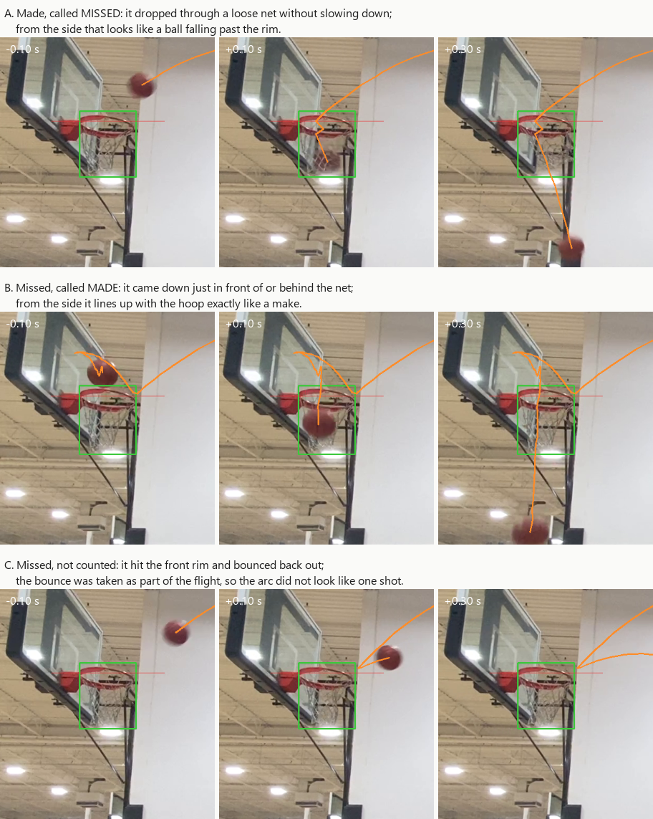
three of the test mistakes, cropped to the hoop (orange: the path followed; green: hoop box; red: rim line)
This is the cleanest number in the project: a new place, new camera positions, a frozen system, scored once. Sessions 6–8 are now used; every change after this is a dev result until new footage is filmed.

9. Dev fixes after the test (2026-10-09 to 10)
Each fix targets an error type seen in the test, but was designed and measured on dev footage only: first gym (sessions 1–4), second gym (5, 9, 10, 11) and the public dev videos.
- Net catch. The makes wrongly demoted as "fell past" reached the rim moving fast sideways (6.5–8 hoop widths per second) and kept only −0.2 to 0.35 of that speed after the crossing: the net stopped them. Balls that really fell past kept moving sideways. A make is no longer demoted when it came in at 3 widths per second or more and kept at most half of it.
- Hoop found automatically. Detector v2 sees gym hoops as rim_only (a rim without its net). The hoop finder takes the biggest rim in each of 60 frames (the nearest hoop looks biggest), the median over frames, and extends it down over the net by 1.27 rim widths. Against the hand-marked hoops it picked the right hoop in all 11 own sessions (IoU 0.81–0.93).
- Shot rules in rim widths. Every distance in the shot rules was measured in heights of the hoop box, which depend on how much net the box covers (0.97–1.60 times as tall as wide across our videos). The rim's width is detected consistently, so all distances are now in rim widths (one value of four tried on dev). With it, the found hoop does as well as the hand-marked one in the second gym (97 of 102 each, up from 92).
- Shots off the front rim. Arc, deflection and fall together are no parabola, so these attempts were discarded. Now the arc up to where the ball first reached the rim is fitted on its own; if it is clean, the shot is judged by where the ball goes (through, outside, or back up).
- Frame rate (2026-10-10, for the phone): the "ball still held" check was a distance per frame and failed at 20 fps; it is now a speed times the detector's median frame interval (section 10.6).
Dev shots called right, after each change | First gym (162) | Second gym (102) | Public dev (98)
System frozen for the test (c78a239) | 149 (92.0%) | 91 (89.2%) | 92 (93.9%)
+ net catch | 151 | 95 | 92
+ shot rules in rim widths | 152 | 97 | 92
+ front-rim shots | 153 | 97 | 92
same, with the automatically found hoop | 153 | 97 | 92
+ frame-rate fix (public dev detections are every 2nd frame) | 153 (94.4%) | 97 (95.1%) | 93 (94.9%)
The front-rim change was used once on dev (a miss off the rim, now counted and called missed) and changed no other call. Dev 94–95% now against 85.6% on the test is not like-for-like: the test predates these fixes, and they were designed on these very shots. New test footage is the real check.

10. The iPhone app (2026-10-10 to 11)
A native Swift app (Basketball-Shot-Tracker-iOS) runs the whole system live on the iPhone 11: detector v2 in Core ML on the Neural Engine, then the static filter, ball tracker and shot judge ported line by line to Swift. It was built and installed from Windows: xtool builds and signs it with a free Apple ID inside WSL Ubuntu and reaches the phone through Apple's Windows driver, with no Mac and no paid developer account.
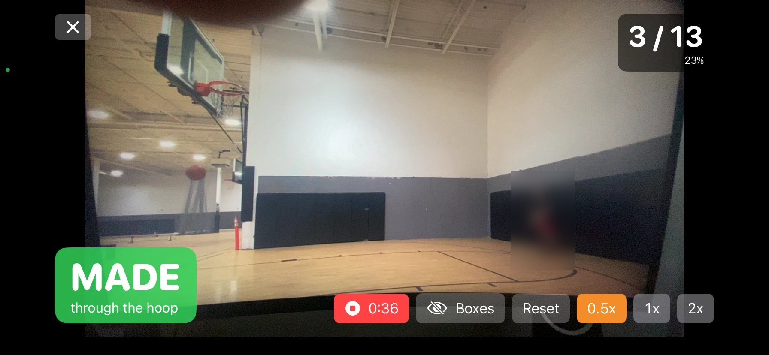
the live screen: call banner, score and FG%, Record, Boxes, Reset and zoom (filming a monitor; person blurred)

10.1 What the app does
- Start screen with filming tips, Start, Sessions and the build's git commit.
- Camera: 1080p at 60 fps, dual-wide lens with zoom 0.5×–5× (pinch or presets), landscape only.
- Finds the hoop by itself (biggest rim_only box plus the net, as in section 9) and follows it between shots, for a bumped or hand-held phone (it lags about 1.5 s; not evaluated offline, where the hoop was fixed).
- MADE / MISSED banner with the reason, score and FG%, Reset, a Boxes toggle and a Check button (detector parity, section 10.3).
- Record: the video plus a session file with every detector frame's boxes, the hoop events, the shot calls, the app build and the model's SHA-256; a Sessions screen plays them back with their calls and exports them as a zip.

10.2 The pipeline on the phone
Step | Method
Letterbox | 1920×1080 to 960×540 by an exact 2×2 average (OpenCV's own result for a half-size resize), centred on grey to 960×544: the pixels PyTorch saw
Detector | YOLOv8s in Core ML, fp16, on the Neural Engine; no NMS inside the model
Decode + NMS | Best class per anchor, kept above confidence 0.15, greedy per-class NMS at IoU 0.7: identical to Ultralytics
Pipelining | Frame N+1 is letterboxed while the model runs frame N (at most 2 in flight): 22 to 28–32 fps
Hoop | Biggest rim_only box per frame, median over about 1.6 s, plus the net; moves only between shots
Tracking and judging | Static filter, ball tracker and shot judge: the Swift port of the Python code, all distances in rim widths

10.3 The detector on the phone matches PyTorch
export_coreml.py converts detector v2 without NMS (fp16 for the phone, fp32 as a reference). export_parity_frames.py saves 24 dev frames as PNG (3 per dev session) with PyTorch's detections; the app's Check button runs its own detector on the same pixels.
60 PyTorch boxes | Matched | Missed / extra | IoU mean (min) | Max conf. difference | Max corner difference
fp32, exact resize | 60 | 0 / 0 | 1.000 (0.999) | 0.000 | 0.0 px
fp16, exact resize (live) | 60 | 0 / 0 | 0.988 (0.959) | 0.013 | 0.7 px
fp16, Apple vImage resize | 60 | 0 / 1 | 0.982 (0.940) | 0.066 | 3.2 px
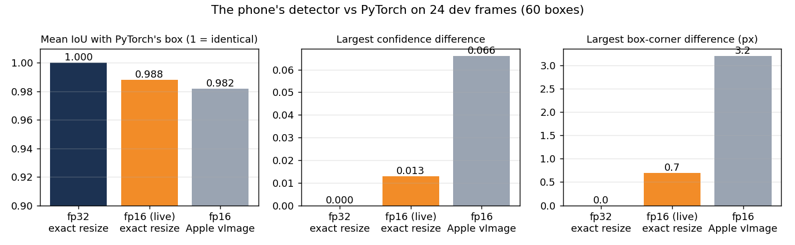
the phone's detector against PyTorch on 24 dev frames (60 boxes)
fp32 reproduces PyTorch exactly, so preprocessing, decoding and NMS are identical; fp16 moves boxes by under a pixel. Apple's resize (a sharper filter) was 5 times further off, which is why the exact 2×2 average is used.

10.4 Speed on the iPhone 11
Measured live on the phone | Value
Camera | 60 fps, 1080p
Detector | 28–32 fps (25 while recording video)
Per frame | letterbox 1.6–1.9 ms, model 30.6–34.9 ms, decode + NMS 0.2–0.3 ms
Frame to call | 45–62 ms
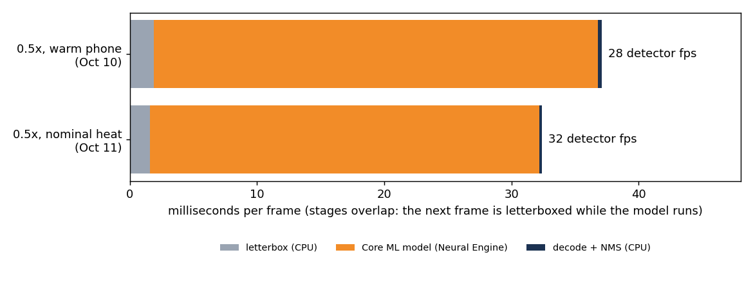
time per detector frame on the iPhone 11 by stage, 2026-10-10 and 11
A first two-stage version ran at about 10 fps because the box decoder was a generic Swift function called across a module boundary, which the compiler did not specialise (24 ms per frame); a non-generic version takes 0.3 ms.

10.5 The tracker and shot judge are the same code
The Swift port is checked against golden cases exported from the Python code (swift test): for every frame the tracked ball and track switches, and every shot call and decision-log line, compared exactly as 64-bit numbers.
Case | Frames | Shot calls | Result
Simulator (every shot type, noise, decoys) | 884 | 7 | Identical
Own session 1 (first gym, dev) | 11,729 | 44 | Identical
Own session 2 (first gym, dev) | 15,059 | 42 | Identical
Own session 5 at every 3rd frame (second gym, dev; the phone's rate) | 5,714 | 30 | Identical
A deliberate change (fixing the frame interval at 1/60 s) makes three of the four cases fail, so the check is not vacuous.

10.6 Frame rate: does the phone's lower rate cost accuracy?
The phone runs the detector on every second or third camera frame. Replaying the saved dev detections with only every Nth frame (replay_eval.py --stride N, every offset) showed that the "ball still held" check, a distance per frame, glued the gather to the arc at 20 fps and the shot was discarded. It is now a speed (4.8 = 0.08 × 60 per second) times the detector's median recent frame interval; at 60 fps nothing changes.
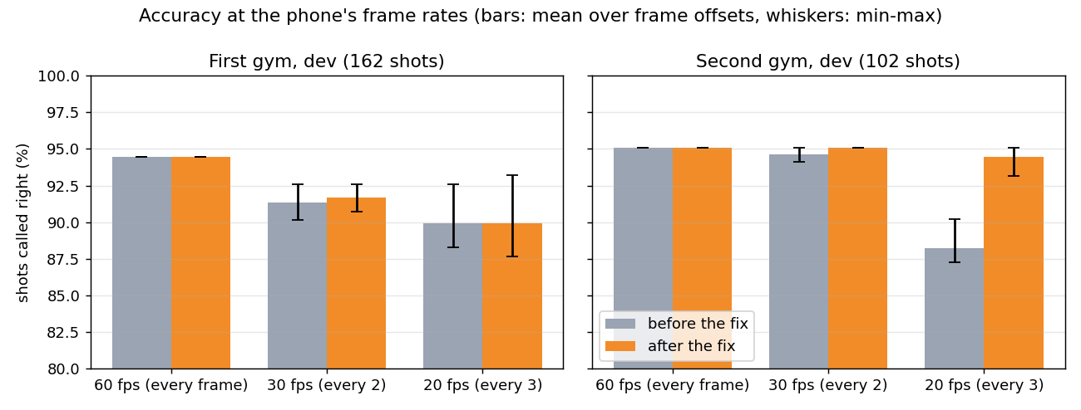
dev shots called right at the phone's frame rates, before and after the fix (bars: mean over frame offsets; whiskers: min–max)
Dev shots called right (before → after) | First gym (162) | Second gym (102)
Every frame (60 fps) | 153 → 153 | 97 → 97
Every 2nd frame (30 fps), 2 offsets | 150, 146 → 150, 147 | 97, 96 → 97, 97
Every 3rd frame (20 fps), 3 offsets | 150, 144, 143 → 151, 144, 142 | 89, 92, 89 → 97, 97, 95
The second gym recovers fully at 20 fps. In the first gym, where the camera was low and close to the hoop, 20 fps still costs up to 11 shots (short flights and less precise crossing points): more frames per second is the remaining lever there, not more tuning.

10.7 Real phone recordings, replayed in Python
import_phone_session.py reads an exported recording, replays its detector frames through the Python pipeline the way the phone ran it (a new shot judge wherever the phone found or reset the hoop) and requires the same calls; with labels it scores them with the same evaluation as every result above.
Recording | Detector fps | Hoop events | Calls | Python replay
30 s, 0.5×, hand-held (first format) | 25.2 | 9 | 4 | 4 of 4 identical
64 s, 1×, judge already running at Record | 32.1 | 20 | 6 | 5 of 6; the other was released before Record
74 s, 0.5×, build d29f83c | 31.5 | 14 | 6 | 6 of 6 identical
A recording started while the judge was running lacks the state the judge had built before it, so a shot in flight at that moment can replay differently. From build d29f83c the judge restarts when recording starts, and a recording replays exactly. These recordings filmed a monitor and were not labelled: they check that the phone runs the Python system, not how accurate it is live.

11. Discussion and limitations
Most of the gain came from the data, not the logic: training data with people on court cut the false "balls" that misled the tracker, and recall on our footage doubled (44.5% to 86.6%). The tracker changes mattered most while the detector was still weak, and cost nothing on side-on footage.
The second-gym test is the project's cleanest number: 85.6% in a place, from camera positions and with a shooter the system had never seen, scored once. Finding shots transferred well (none invented, 3 of 90 missed); the made/missed call is the weak part, and its errors lean towards makes called missed, mostly where one sideline camera cannot tell a ball dropping through the net from one dropping just beside it.
The phone work shows the system runs live without changing what it computes: the detector, tracker and shot judge reproduce the Python reference, so the offline numbers describe the app at a given frame rate. At the phone's 25–32 fps the frame-rate fix keeps the second gym's dev shots, but the first gym still loses up to 11 of 162 at 20 fps.

11.1 Threats to validity
- Re-used test sets (2026-10-07). Both test sets in section 5 had been scored before; the low first own-footage score (37.8%) motivated the detector retraining. Nothing was tuned on them and the system was frozen first, but those are re-tests, not first looks. Sessions 2–4 have since become dev footage; section 8 is the first-look number.
- One test gym, one morning. The 85.6% comes from one gym, one shooter and one camera spot per shot type, filmed in one morning; 90 shots give a 95% interval of 77–91%.
- Small samples. 90–119 test shots give 95% intervals of about ±7–8 points; differences of 1–3 points on dev are one or two shots.
- Dev fixes not yet tested. Net catch, rim widths, front-rim shots and the frame-rate fix were designed on dev footage after the test; their 94–95% dev numbers overstate what new footage will show.
- Live accuracy not measured. The phone runs the same code (sections 10.3–10.7), but no labelled session recorded through the app exists yet; the recordings so far filmed a monitor.
- One camera at the sideline cannot see depth. A ball dropping just in front of or behind the net can look like a make, and a fast drop through a loose net like a miss: most of the test errors.
- Uneven sessions. Session 2 alone accounted for 14 of the 16 first-gym shots not found on 2026-10-07 (section 7.1 found 39 of its 41 afterwards, on dev).

11.2 Mistakes caught along the way
Date | What went wrong | How it was caught | Fix
2026-10-11 | A recording started while the shot judge was running replayed one call differently in Python | Python replay of the phone's recording | The judge restarts when recording starts (build d29f83c): 6 of 6 identical
2026-10-10 | The two-stage phone pipeline ran at about 10 fps | Per-stage timing on the phone: decoding took 24 ms | Non-generic decoder (0.3 ms): 28–32 fps
2026-10-10 | The held-ball check was per frame, so at the phone's 20 fps second-gym dev shots dropped from 97 to 89–92 | Replays of saved detections at every 2nd and 3rd frame | A speed times the median frame interval (section 10.6)
2026-10-10 | USB pass-through (usbipd) into WSL corrupted large transfers, so app installs failed | Install errors and usbmuxd "message too large" logs | The phone is reached through the Apple Devices relay instead
2026-10-10 | The iPhone app was pushed onto the GitHub repository of an older Expo prototype | Repository history on GitHub | Repository renamed Basketball-Shot-Tracker-iOS; the prototype kept locally
2026-10-08 | Detector v3 scored higher validation mAP but lost dev shot calls (93.9% to 88.8% public) | Shot-call replays on dev footage, not just mAP | v2 kept; shot calls on unseen footage decide
2026-10-07 | The Oct 7 report said the first-gym camera was on the baseline; it was on the sideline | Re-reading against the footage | Corrected in README and RESULTS on 2026-10-07 and in this report
2026-10-07 | Old portrait videos run at 960 px instead of the original 1280 px, which looked like a 5-point tracker regression | Replays at matching settings showed both trackers scoring the same | Image size chosen by video shape; settings saved per run; mismatch warning
2026-10-06 | First training run used about 8 GB on a 6 GB card and ended in a graphics-driver reset after 15 minutes | Windows event log at the moment the process died | Batch size 2 (5.8 GB), same time per epoch
2026-10-06 | Evaluator would have attached old video N's setup notes to new session N | Code review while generalising the scripts | Setup files looked up next to each label folder
2026-10-06 | Automatic hoop finding picked the far-wall hoop in 3 of 4 sessions | Visual check of each hoop box | Hoop set once per session; since 2026-10-09 the biggest-rim hoop finder (section 9)

12. Conclusion and next steps
In seven days the system went from 77.7% on public test videos to 85.6% on a first-look test in a gym it had never seen, and from a PC script to a live iPhone app that computes the same calls as the Python reference at 28–32 detector frames per second. The open question is now one number: accuracy live on the phone, on newly filmed, blind-labelled sessions.
- ☐ Decide the app features to include before freezing a test build (session type with per-type FG%, a sound on each call, saved session history)
- ☐ Live test: fix the split before filming; freeze the app build (commit on the start screen and in each recording); tripod at the sideline, 0.5×; record every session; label blind; score once with import_phone_session.py --labels (the replay must match)
- ☐ Measure the dev fixes since 2026-10-09 (net catch, rim widths, front-rim shots, frame rate) on that new footage
- ☐ Raise the detector rate where 20 fps still costs shots (first-gym camera position)
- ☐ Train a future detector on footage from many places, each frame counted once

References and credits
- Basketball Detection v6 by the Roboflow user "Hooper", CC BY 4.0: extra detector training data.
- basketball detection v5 by the Roboflow user "hotshot", CC BY 4.0: original detector training data.
- gbikushev/Basketball-Score-Detection-ComputerVision: source of the 16 public evaluation videos (no licence; used locally only, not redistributed).
- Ultralytics YOLO (AGPL-3.0), PyTorch, OpenCV, NumPy, imageio-ffmpeg, pytest.
- coremltools (BSD-3-Clause): converting the detector to Core ML.
- xtool: building, signing and installing the iPhone app from Linux (WSL).
- chonyy/AI-basketball-analysis: prior work studied for the problem; no code used.
- Project repositories: NathanielRecto/Basketball-Shot-Tracker (research) and NathanielRecto/Basketball-Shot-Tracker-iOS (iPhone app).

